MASTER DESIGN DOCUMENT (MDD)
Project Title: Data-Driven Crop Yield Analysis Using Python, SQL, and Power BI
Domain: Data Analytics
Submitted by: Vishal B. Dokhe
Mentor: Shreya Chittranshi
Course: Capstone Project Submission
Institution: Skillians
Academic Year: 2024–2025

1. INTRODUCTION
In recent years, data analytics has become a cornerstone of decision-making across industries, including agriculture. The agricultural sector generates vast amounts of data related to crop production, rainfall, land usage, and seasonal variations. However, raw agricultural data is often unstructured, inconsistent, and difficult to interpret without proper processing and analytical tools. This creates a gap between data availability and actionable insights.
The objective of this capstone project is to design and implement an end-to-end data analytics solution for crop yield analysis using modern analytical tools such as Python, SQL, and Power BI. The project demonstrates how raw crop yield data can be cleaned, transformed, stored, analyzed, and visualized to support informed decision-making.
This project follows an industry-standard workflow where Python is used for data cleaning and exploratory data analysis (EDA), SQL is used for structured data storage and querying, and Power BI is used for creating interactive dashboards. By integrating these tools, the project showcases a scalable and practical approach to real-world data analytics.

2. PROBLEM STATEMENT
Agricultural datasets often suffer from several challenges such as missing values, duplicate records, inconsistent units, and lack of proper formatting. These issues make it difficult to analyze crop performance and identify meaningful trends.
The major problems identified are:
- Raw crop yield data is unclean and inconsistent
- Data stored in flat files (CSV) is not suitable for complex analysis
- Manual analysis is time-consuming and error-prone
- Lack of interactive visualization limits decision-making
Hence, there is a need for a structured data analytics system that can clean, store, analyze, and visualize crop yield data efficiently.

3. OBJECTIVES OF THE PROJECT
The primary objectives of this project are:
- To clean and preprocess raw crop yield data using Python
- To perform exploratory data analysis to understand trends and patterns
- To design a relational database using SQL
- To execute analytical SQL queries for insights generation
- To develop interactive dashboards using Power BI
- To support data-driven decision-making in agriculture

4. SCOPE OF THE PROJECT
The scope of this project includes:
- Analysis of historical crop yield data
- Data cleaning and transformation
- Descriptive and diagnostic analytics
- Dashboard-based visualization
The project does not include:
- Predictive modeling
- Real-time data streaming
- External API integrations

5. LITERATURE REVIEW
Previous studies emphasize the importance of data analytics in agriculture for improving productivity and sustainability. Python is widely used for data manipulation due to its rich ecosystem of libraries such as Pandas and NumPy. SQL remains the standard for relational data storage and querying. Power BI is recognized for its ability to create interactive and user-friendly dashboards.
Research indicates that integrating multiple analytical tools enhances data accuracy, scalability, and interpretability, making analytics solutions more effective.

6. SYSTEM OVERVIEW
The system is designed using a layered architecture:
- Data Source Layer – Raw crop yield dataset (CSV)
- Processing Layer – Python (Jupyter Notebook)
- Storage Layer – MySQL Database
- Visualization Layer – Power BI
This layered approach ensures modularity and scalability.

7. METHODOLOGY
The methodology followed in this project is systematic and sequential:
- Data Collection
- Data Cleaning and Preprocessing (Python)
- Exploratory Data Analysis (EDA)
- Database Design and Data Insertion (SQL)
- Analytical Query Execution
- Dashboard Development (Power BI)
- Insight Generation and Interpretation
Workflow:

8. DATA DESCRIPTION
The dataset consists of crop yield records with attributes such as:
- Crop Name
- State / Region
- Year
- Season
- Area Cultivated
- Rainfall
- Production
- Yield
The dataset contains thousands of records representing multiple crops across different regions and years.

9. TOOLS AND TECHNOLOGIES USED
Tool | Description
Python | Data cleaning & EDA
Pandas | Data manipulation
NumPy | Numerical operations
Jupyter Notebook | Development environment
MySQL | Relational database
SQL Workbench | Query execution
Power BI | Data visualization

10. SYSTEM ARCHITECTURE
The system architecture represents the flow of data from raw files to dashboards. Python processes the raw data and exports clean datasets, which are then imported into MySQL. Power BI connects to the database to generate dashboards.

11. DATA CLEANING AND PREPROCESSING (PYTHON)
Data cleaning is a critical step in this project. The following operations were performed:
- Removal of duplicate records
- Handling missing values
- Standardizing column names
- Converting data types
- Removing invalid or zero values
These steps improved data quality and reliability.

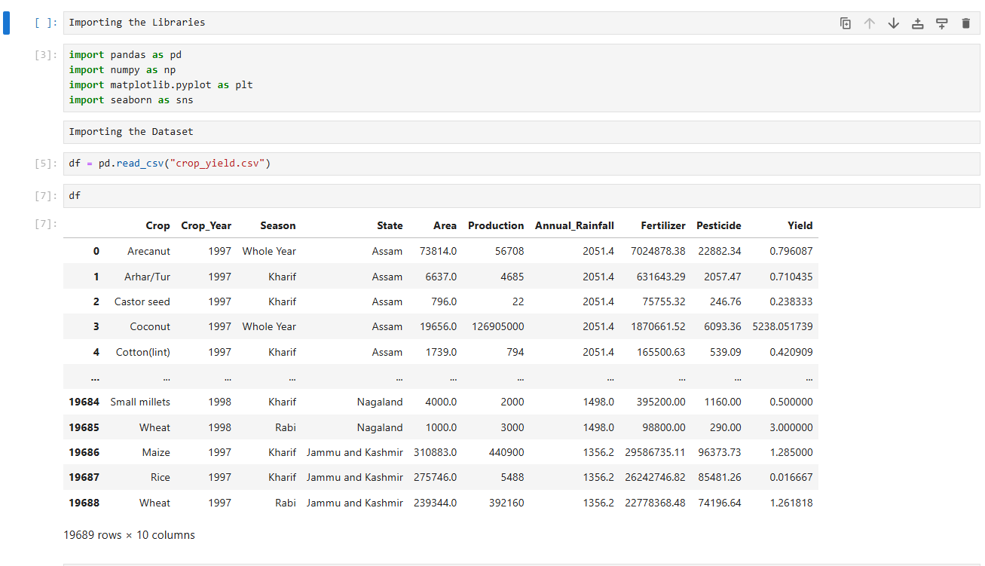
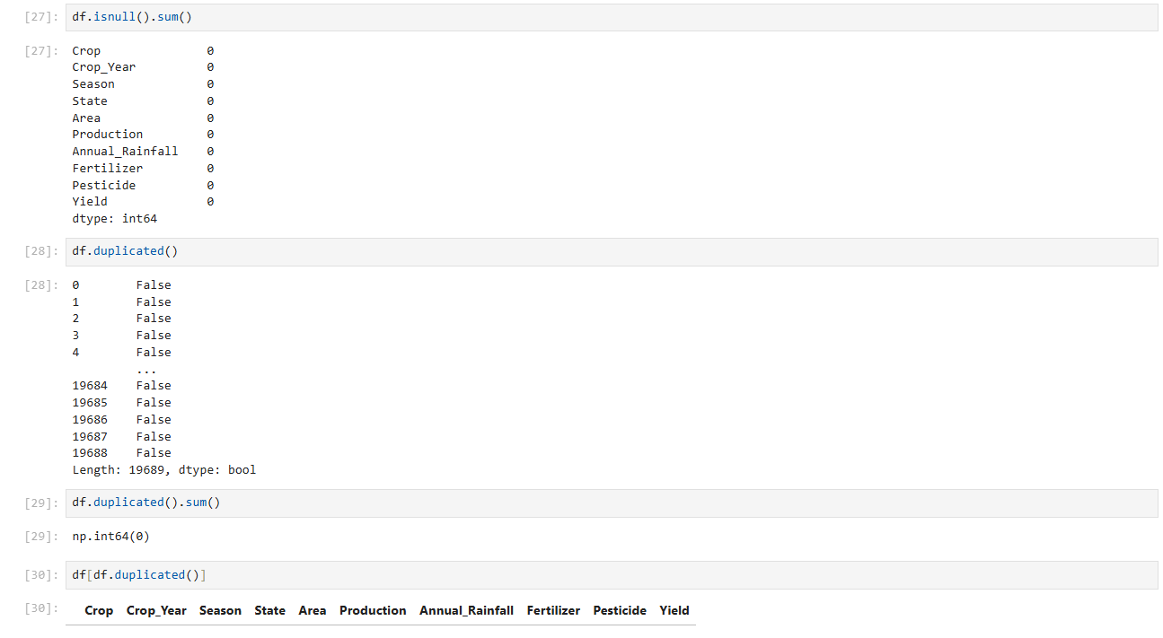

12. EXPLORATORY DATA ANALYSIS (EDA)
EDA was performed to understand:
- Crop-wise production trends
- Rainfall vs yield relationships
- Year-wise growth patterns
Visualizations such as bar charts, line plots, and summary statistics were used to identify trends and outliers.

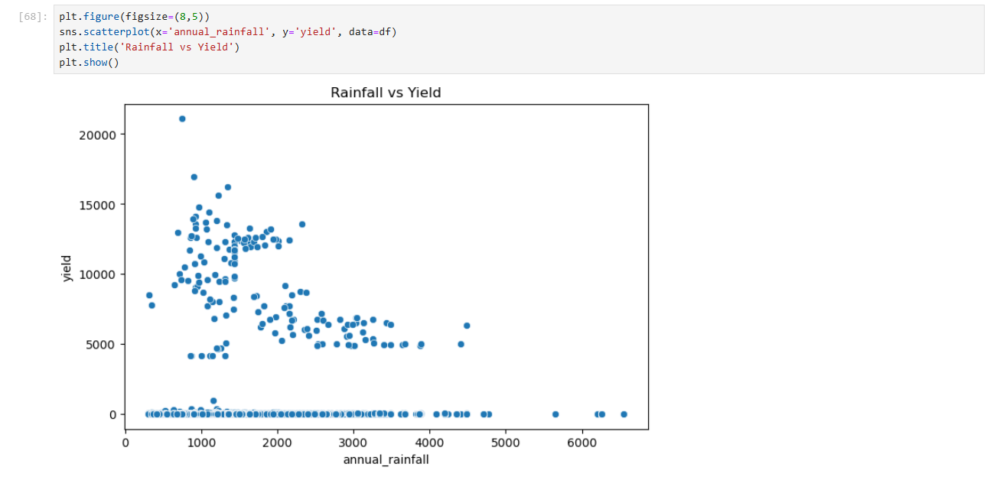

13. DATABASE DESIGN AND SQL IMPLEMENTATION
A relational database was designed to store cleaned data. The database schema ensures normalization and data integrity.
Key SQL operations included:
- Table creation
- Data insertion
- Indexing
- Constraints
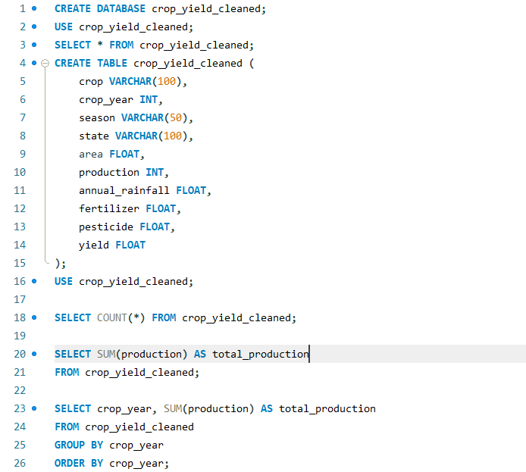

14. ANALYTICAL SQL QUERIES
SQL queries were written to:
- Calculate total production per crop
- Identify top-performing regions
- Analyze yearly growth trends
- Compute average yield
These queries helped in generating structured insights.
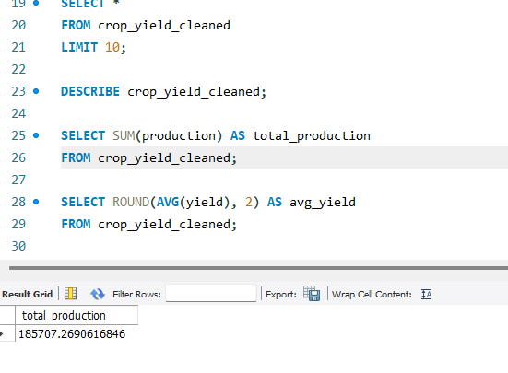

15. POWER BI DASHBOARD DEVELOPMENT
Power BI was used to create interactive dashboards. Features include:
- KPI cards
- Filters and slicers
- Trend charts
- Region-wise analysis
The dashboard enables users to explore data dynamically.
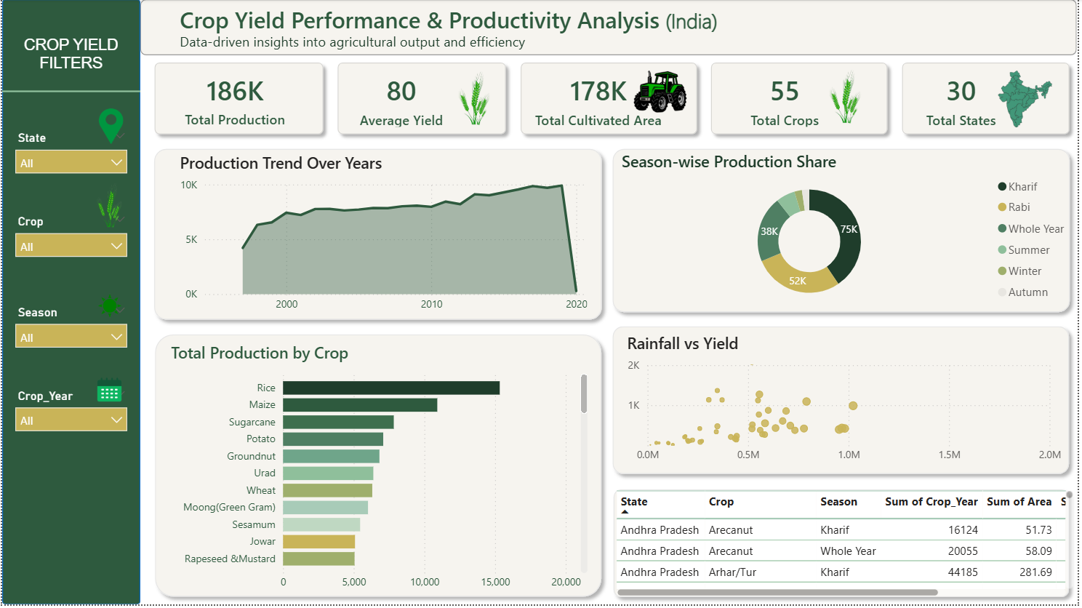

16. RESULTS AND INSIGHTS
Key insights obtained include:
- Certain crops show consistent yield growth
- Rainfall significantly impacts production
- Regional variations influence productivity
These insights can support agricultural planning.

17. VALIDATION AND TESTING
Validation was performed by cross-checking Python, SQL, and Power BI results to ensure consistency and accuracy.

18. LIMITATIONS
- Static historical dataset
- No predictive analytics
- Limited external factors considered

19. CONCLUSION
This project successfully demonstrates an end-to-end data analytics solution using Python, SQL, and Power BI. The structured workflow ensures clarity, accuracy, and scalability, making it suitable for real-world applications.

20. FUTURE SCOPE
Future enhancements may include:
- Machine learning-based yield prediction
- Real-time dashboards
- Cloud deployment (AWS / Azure)

21. PROJECT TIMELINE
Phase | Duration
Data Collection | 2 Days
Cleaning & EDA | 2 Days
SQL Analysis | 2 Days
Power BI Dashboard | 1 Day

22. REFERENCES
- Python Official Documentation
- MySQL Reference Manual
- Microsoft Power BI Documentation

